Contribution Title
Contribution subtitle (if any)

FIRST AUTHOR
Princeton University, Princeton NJ 08544, USA
e-mail@email.com

SECOND AUTHOR
Princeton University, Princeton NJ 08544, USA
e-mail@email.com

ABSTRACT
The abstract should summarize the contents of the paper in short terms, i.e. 150-250 words.

FIRST SECTION (All caps)
The contribution should not exceed the 40000 characters.
Please note that the first paragraph of a section or subsection is not indented. The first paragraphs that follow a table, figure, equation etc. does not have an indent, either.
Subsequent paragraphs, however, are indented.
Footnotes can also be added, please note that the apex is always after the punctuation sign, with no space between the punctuation and the number.
The journal uses the referencing system APA Style, 7th edition. All cited works– books, chapter, articles, conference papers, games, movies, and so on – must be present in the current text as (Surname, year), and be included in the references.

A Subsection Sample
Please note that the first paragraph of a section or subsection is not indented. The first paragraph that follows a table, figure, equation etc. does not have an indent, either.
Subsequent paragraphs, however, are indented.
Sample Heading (Third Level). Only two levels of headings should be numbered. Lower level headings remain unnumbered; they are formatted as run-in headings.
Sample Heading (Forth Level). The contribution should contain no more than four levels of headings. The following Table 1 gives a summary of all heading levels. Please always recall a Table in the current text.
Table 1 – Table captions should be placed above the tables.
Column title | Column title | Column title
Column text | Column text | Column text
Column text | Column text | Column text
Column text | Column text | Column text

A figure caption is always placed below the illustration. Please always recall a figure in the current text among brackets ( Fig. 1) or directly in text. Namely, Fig.1 shows an image followed by its caption.
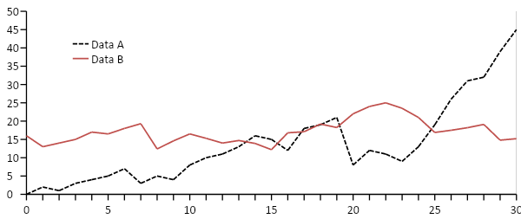
Figure 1 – A figure caption is always placed below the illustration. Short captions are centered, while long ones are justified. The macro button chooses the correct format automatically.
References use APA 7th style. Here is an example.

REFERENCES
Bateson, G. (1956). The message “This is play.” Group Processes, 2, 145–241.
Caillois, R. (1957). Unity of play: Diversity of games. Diogenes, 5(19), 92–121.
Salen, K., & Zimmerman, E. (2004). Rules of Play: Game Design Fundamentals. The MIT Press.

Footnotes can also be added.

